Project Based Learning -II Report on

**Object Avoiding Robot**

**By**

**Ms. Sakshi Gorivale Mr. Kedar Mule**

**Mr. Abhijeet Shinde Mr. Anirudha Landage**

**Guide**

**Prof. Pooja Wale**



**Department of Computer Engineering**

**Indira College of Engineering and Management**

**[2021-22]**

Indira College of Engineering and Management



C E R T I F I CAT E

This is to certify that –

**Ms. Sakshi Gorivale**

**Mr. Abhijeet Shinde**

**Mr. Kedar Mule**

**Mr. Anirudha Landage**

have successfully completed the PBL II entitled “**Object Avoiding Robot**” under my supervision in the partial fulfilment of Second Year of Engineering – Computer Engineering of Savitribai Phule Pune University.

Date :

Place :

**Dr. Soumitra Das**

**Prof. Pooja Wale Prof. Manjusha Tatiya**

Guide PBL Coordinator

**Dr. Soumitra Das Dr. Sunil Ingole**

Head of Department Principal

**ACKNOWLEDGEMENT**

With immense pleasure, we are presenting this Project Based Learning II as a part of the curriculum of S.E Computer Engineering. We wish to thank all the people who gave us endless support right from the stage the idea was conceived.

We are heartily thankful to **Prof. Pooja Wale**(Guide) whose encouragement, guidance and support from the initial to the final level enabled us to develop an understanding of the subject. We would also like to thank **Dr.** **Soumitra Das** (HOD, Computer Engg. Department), **Prof. Manjusha Tatiya** (PBL Coordinator) and **Dr. Sunil Ingole** (Principal),for giving us opportunity to make project on this interesting topic.

This project would not be possible without help of library department who helped us gathering the information from various sources. Lastly, we offer our regards to all those who supported us in any respect during the completion of PBL II project.

**INDEX**

**CONTENTS**

1.Problem Statement………………………………………………………**4**

1.1 Introduction……………………………………………………5

2.Motivation……………………………………………………………….**6**

3.Objectives………………………………………………………………..**7**

4.Methodology…………………………………………………………….**8**

4.1Robot working principle……………………………………….8

4.2System block diagram………………………………………….9

5.Software and Hardware Requirements…………………………………..**10**

5.1Hardware requirements……………………………………….10

5.1.1Arduino Uno…………………………………………….10

5.1.2Motor Driver Shield…………………………………….11

5.1.3Ultrasonic Sensors………………………………………12

5.1.4Motors……………………………………………………13

5.1.5Servo motor………………………………………………14

5.2Software Requirements………………………………………….15

5.2.1Arduino IDE………………………………………………15

6.Implementation…………………………………………………………….**15**

7.Results……………………………………………………………………...**20**

8.Challenges faced……………………………………………………………**21**

9.Conclusion and future scope……………………………………………….**22**

10.References…………………………………………………………………**23**

**Chapter1**

**PROBLEM STATEMENT**

The primary purpose of this bot is to traverse forward autonomously and change directions if it encounters any significant obstacle in its path. The bot will avoid any obstacle big enough to be detected by the ultrasonic sensors mounted on the front side. A necessary requirement of every autonomous mobile robot is obstacle avoidance. This obstacle avoidance feature is of high importance in a robot’s navigation system in an unknown area so as to prevent collisions during its operation. It is necessary for an autonomous robot to avoid collisions in order to prevent damage to the object or to the robot itself. Application areas where obstacle avoidance is necessary include automatic vacuum cleaners and helicopters. Even in robots which work in a familiar environment and the path of the robot has been adequately defined, some environmental changes could occur and cause the robot to run into an object in its way so it is necessary for the robot to be able to adapt to the change by avoiding any objects in its path. This problem of effective trajectory planning is what has led to the need for a robot that can detect and avoid objects in a pre-computed path, or objects that appear suddenly. The solution to this trajectory problem involves the use of sensors by the robot to detect objects and avoid them thereby making the robot to be more independent since it would not require external influence. This project proposes robotic vehicle that has an intelligence built in it such that it directs itself whenever an obstacle comes in its path. So, to protect the robot from any physical damages. This can be design to build an obstacle avoidance robotic vehicle using ultrasonic sensors for its movement. A micro-controller (AT mega 328P) is used to achieve the desired operation. An ultrasonic sensor is used to detect any obstacle ahead of it and sends a command to the micro-controller. Depending on the input signal received, the micro-controller redirects the robot to move in an alternate direction by actuating the motors which are interfaced to it through a motor driver.

**INTRODUCTION**

The application and complexity of mobile robots are slowly growing every day. They are gradually making their way into real world settings in different fields such as military, medical fields, space exploration, and everyday housekeeping. Motion being a vital characteristic of mobile robots in obstacle avoidance and path recognition has a major impact on how people react and perceive an autonomous system. This enables an autonomous robot to be able to navigate from one place to another without human intervention. Computer vision and range sensors are primary object detection methods used in mobile robots’ detection. Computer vision as an obstacle detection method is more rigorous and expensive technique than the range sensors’ method. However, most commercial autonomous robots use range sensor to detect obstacles. The use of radar, ultrasonic sensor for developing an obstacle detection system had started as early as the 1980’s. Although, after testing these technologies it was concluded that the radar technology was the most suitable for use as the other two technology options were prone to environmental constraints such as rain, ice, snow, dust and dirt. The radar approach was also a very cost effective technology both for the present and the future. presented a method using a single charge-coupled device (CCD) camera in conjunction with a spherically shaped curved reflector which enables ultra-wide angle imaging. The sensors are not limited to obstacle detection.. Finally, the use of ultrasonic sensor for an obstacle avoidance robot vehicle to create a clear path for locomotion has been presented in. The focus of this study is placed on designing a simple, cost effective obstacle avoidance autonomous system using Two pairs of heterogonous sensors and evaluate its performance.

**Chapter2**

**MOTIVATION**

The idea of an autonomous robot is not a new one. Every company that uses mobile robots to perform tasks would like the robot to be able to carry out its functions effectively without any external control. With the advancement in the GPS technology, achieving the independent robot movement is closer to reality. However, the concern of how the robot sees and interacts with its environment must be addressed before the robot is used. To address this concern, sensors are used to collect enough environmental data that the robot interprets for smooth navigation of the robot. This method of addressing the concern leaves three questions: is it possible for a sensor to collect enough data for collision-free movement? Also, is there a fast and effective method of interpreting this data to the robot? Lastly, after interpretation, can the robot react and make correct decisions as quick and precise as a human would in the same environment? These are questions that must be answered to allow for human-free robot movement.

**Chapter3**

**OBJECTIVES**

• The robot should have the capacity to detect obstacles in its path based on a predetermined threshold distance.

• After detection of an obstacle, the robot should be able to change its direction to a relatively open path by making an autonomous decision.

• The robot should not require any external control during its operation.

• The robot should be able to measure distance between itself and an obstacle in real time.

• The robot should be able to operate effectively in an environment which is unknown to it.

**Chapter4**

**METHODOLOGY**

**Robot Working Principle :-**

The robot uses the Ultrasonic sensor to measure the distance in front of it then it moves. As the distance reduces, the robot interprets it as the presence of an obstacle. As soon as the robot detects the obstacle, it stops and moves back a few cm then looks left and right before moving to a free path.

**Hardware Components :-**

• 1x Arduino UNO R3

• 1x2 Wheel Robot Chassis(Includes Motors)

• 1x HC-SR04 Ultrasonic sensor

• 1x HC-SR04 Ultrasonic sensor holder

• 1x L293D Motor Driver Shield

• 1x SG90 Servo Motor

• 2x 9V Battery

• 1x 9V Battery clip without DC jack

• 1x 9V Battery clip with DC jack

• 1x Power Switch

• Jumper wires

**System Block Diagram:-**

Figure shows the Flow Chart of the working of the obstacle avoidance robot. Initially it checks obstacle within 35cm.If there is an obstacle it stops moving and turns towards left and checks if there is an object closer than 35 cm . The check has two possible outcomes, yes or no. Yes, meaning that there is indeed some object closer than 30 cm. No, meaning that there is no objects detected within 30cm. If there is nothing within 30 cm the robot can simply move forward as the path is clear. If there is something closer than 30 cm the robot must perform obstacle avoidance .The first stage of obstacle avoidance is to stop the robot! If you don't stop the robot

immediately it will crash! After the robot has stopped it needs to see what way it should go. It does this by looking both directions, much like you should when you cross the road. First the robot turns left, takes a reading, turns right, and takes a reading. Another check occurs to see what direction is the best way to go. If left is the way to go it has to turn back to the left and then go forward. If right is the way to go the robot simply moves forward as it is already facing in the right direction.

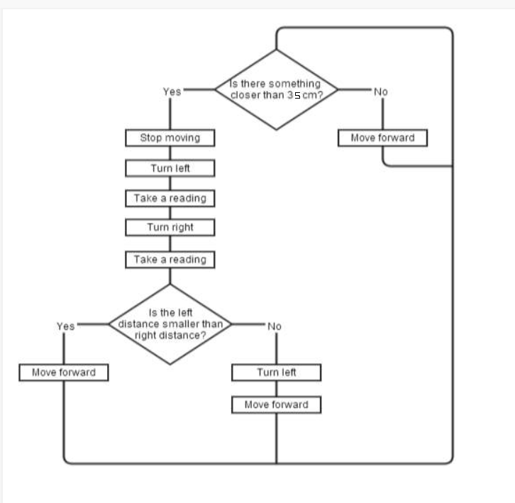

**Chapter5**

**SOFTWARE AND HARDWARE REQUIREMENTS**

**Hardware Requirements :-**

**1.Arduino UNO**

* Arduino/Genuino Uno is a microcontroller board based on the ATmega328P. It has 14 digital input/output pins (of which 6 can be used as PWM outputs), 6 analog inputs, a 16 MHz quartz crystal, a USB connection, a power jack, an ICSP header and a reset button.
* It contains everything needed to support the microcontroller; simply connect it to a computer with a USB cable or power it with a AC-to-DC adapter or battery to get started.
* You can tinker with your UNO without worrying too much about doing something wrong, worst case scenario you can replace the chip for a few money and start over again.
* **Arduino UNO Power Overview**

External power supply voltage: 7V to 12V connector

USB power or Externally via barrel jack connector

* Arduino UNO Pins-

|  |  |
| --- | --- |
| **Pins** | **Functions** |
| Vin | Voltage from External power jack |
| 5V | 5v output from on-board Voltage regulator chip |
| 3.3V | 3.3v output from on board voltage regulator chip |
| GND | 3 pin s for ground |
| IOREF | Tied to 5v, tells Arduino shield voltage level from which Arduino board operates |
| Reset | From RESET pin on MCU, tied to VCC through 10K resistor pull to GND to reset |

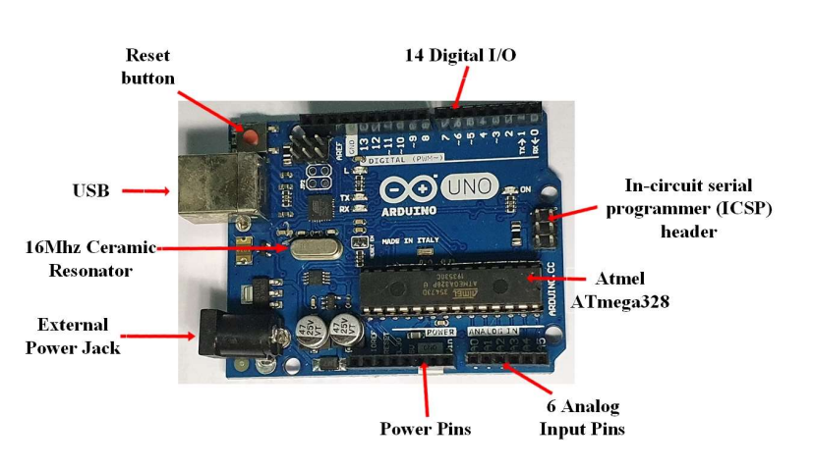

**2.Motor Driver Shield**

* The L293D is high voltage, high current Integrated citcuit which is used to drive DC motors with a power supply of up to 36v. This chip is able to supple a maximum of 600mA per channel. This chip is also known as a type of H-Bridge as it enables a voltage to be applied across a load in either direction to an output.
* L293D is a typical Motor driver or Motor Driver IC which allows DC motor to drive on either direction. L293D is a 16-pin IC which can control a set of two DC motors simultaneously in any direction. It means that you can control two DC motor with a single L293D IC.Dual H-bridge Motor Driver integrated circuit (IC).
* **Features of the Motor Driver Shield-**
* It has to connections to allow for 5v servos to be connected to the Arduino’s high resolution dedicated timer
* It has up to 4 bi-directional DC motors with individual 8-bit speed selection
* It has up to 3 stepper motors with single coil, double coil, interleaved or micro-stepping.
* It has 4 H-Bridges
* It has Pull down resistors to disable motors during power up
* The Arduino reset button is brought to the top
* It is compatible with Mega, UNO & Duemilanove
* Its dimensions are: 69mm x 53mm x 14.3mm

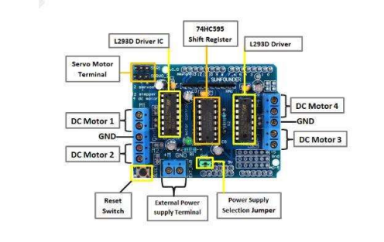

**3.Ultrasonic Sensor**

* The sonic waves emitted by the transducer are reflected by an object and received back in the transducer. After having emitted the sound waves, the ultrasonic sensor will switch to receive mode. The time elapsed between emitting and receiving is proportional to the distance of the object from the sensor.
* Ultrasonic Sensor Features-
* It has a 5V DC power supply
* Its Quiescent current is less than 2mA
* Its working current is 15mA
* Its effectual angle is less than 15 degrees
* Its ranging distance is between 2cm – 400cm/1” – 13ft
* Its Resolution is 0.3cm
* Its measuring angle is 30degrees
* Its Trigger pulse width is 10uS
* Its dimension is 45mm x 20mm x 15mm
* Ultrasonic Sensor Pins-

|  |  |  |
| --- | --- | --- |
| Pin Number | Pin Name | Description |
| 1 | VCC | This is used to power the sensor with 5V |
| 2 | Trigger | This is an Input pin which has to be kept high for 10us to initialize measurement by sending Ultrasound wave. |
| 3 | Echo | This is an output pin which goes high for a period of time equal to the time taken for the Ultrasonic wave to return back to the sensor. |
| 4 | Ground | This pin is connected to the ground of the system |

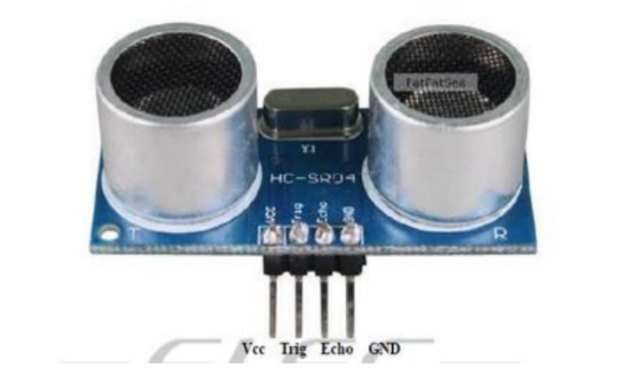

**4.Motors**

* A DC motor in simple words is a device. An Electric DC motor is a machine which converts electric energy into
* mechanical energy.
* This DC or direct current motor works on the principal, when a current carrying conductor is placed in a magnetic field, it experiences a torque and has a tendency to move.
* This is known as motoring action. If the direction of current in the wire is reversed, the direction of rotation also reverses.
* A gear motor consists of a gearbox and a motor. The addition of a gear head to a motor reduced the speed while increasing the torque output.

Important parameters in gear motors include:

--Speed (rpm)

--Efficiency (%)

--Torque (lb.-in)

* The factors to consider before selecting a gear motor for any application include:

--Speed

--Load

--Torque requirements

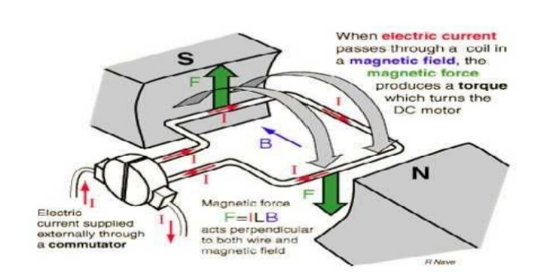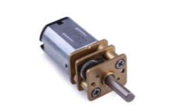

**Necessary Tools and Machines**

* 1x Soldering Iron
* Solder
* Glue Gun
* drivers
* Arduino IDE

**5.Servo Motor**

A servomotor (or servo motor) is a simple electric motor, controlled with the help of servomechanism. If the motor as a controlled device, associated with servomechanism is DC motor, then it is commonly known as a DC Servo Motor. If AC operates the controlled motor, it is known as a AC Servo Motor.

A servomotor is a linear actuator or rotary actuator that allows for precise control of linear or angular position, acceleration, and velocity. It consists of a motor coupled to a sensor for position feedback. It also requires a relatively sophisticated controller, often a dedicated module designed specifically for use with servomotors.

Pins of Servo motors-

|  |  |
| --- | --- |
| **Pins** | **Functions** |
| Power | Typically red connected to 5V pin on Arduino Board |
| Ground | Typically Black or brown and should be connected to ground pin on Arduino board |
| Signal | Typically yellow or orange and should be connected to digital pin on Arduino board |

**Servo motor applications**-

* Robotics
* Animatronics
* Radio Control Cars

**Servo motor advantages-**

* Low cost- (RC servos) Smaller sized servos can be purchased on low cost.
* Variety - There is a wide range of sizes and torque ratings.
* Simple to control - Using logic level pulses from a microcontroller or a dedicated servo controller.

**Software Requirements :-**

**1.Arduino Software(IDE)**

* **"**Uno" means one in Italian and was chosen to mark the release of Arduino Software (IDE) 1.8.19
* The Uno board and version 1.8.19 of Arduino Software (IDE) were the reference versions of Arduino, now evolved to newer

releases.

**Chapter6**

**IMPLEMENTATION**

**Constructing the Robot**

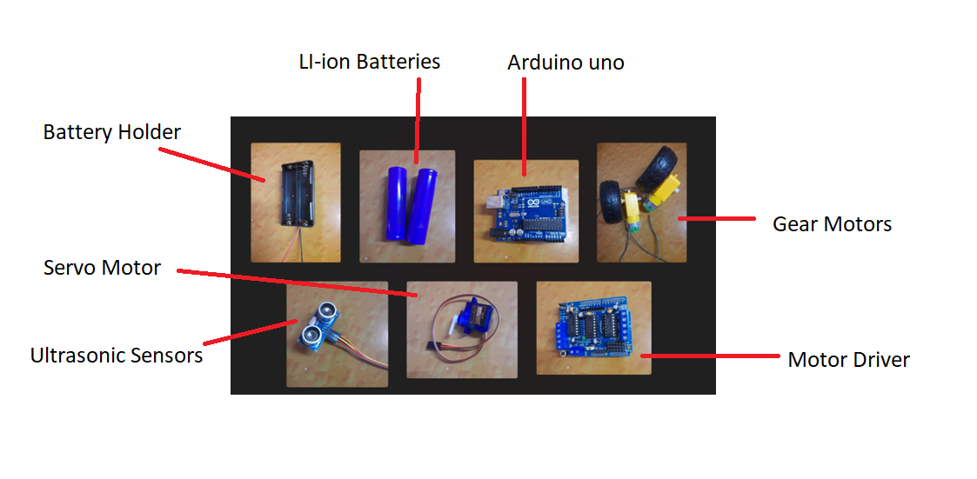

**Step 1**

Attach Motors to battery Holder and connect motors and wheels by soldering wires to the positive and negative terminals of motors

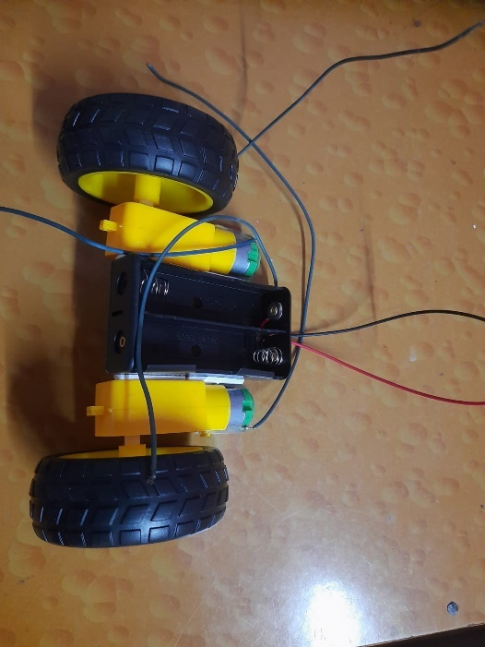

**Step 2**

Attach the switch, battery clip, SG90 Servo Motor and Arduino UNO to the chassis. After this, mount the L293D Motor Driver shield on the Arduino UNO R3 and the HC-SR04 to the Servo motor.

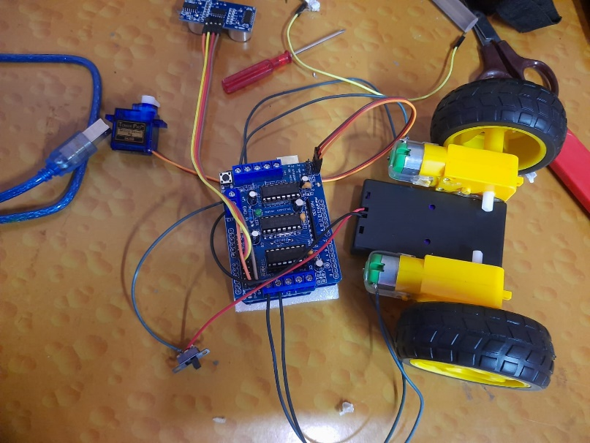

**Step 3**

Wire up components as follow

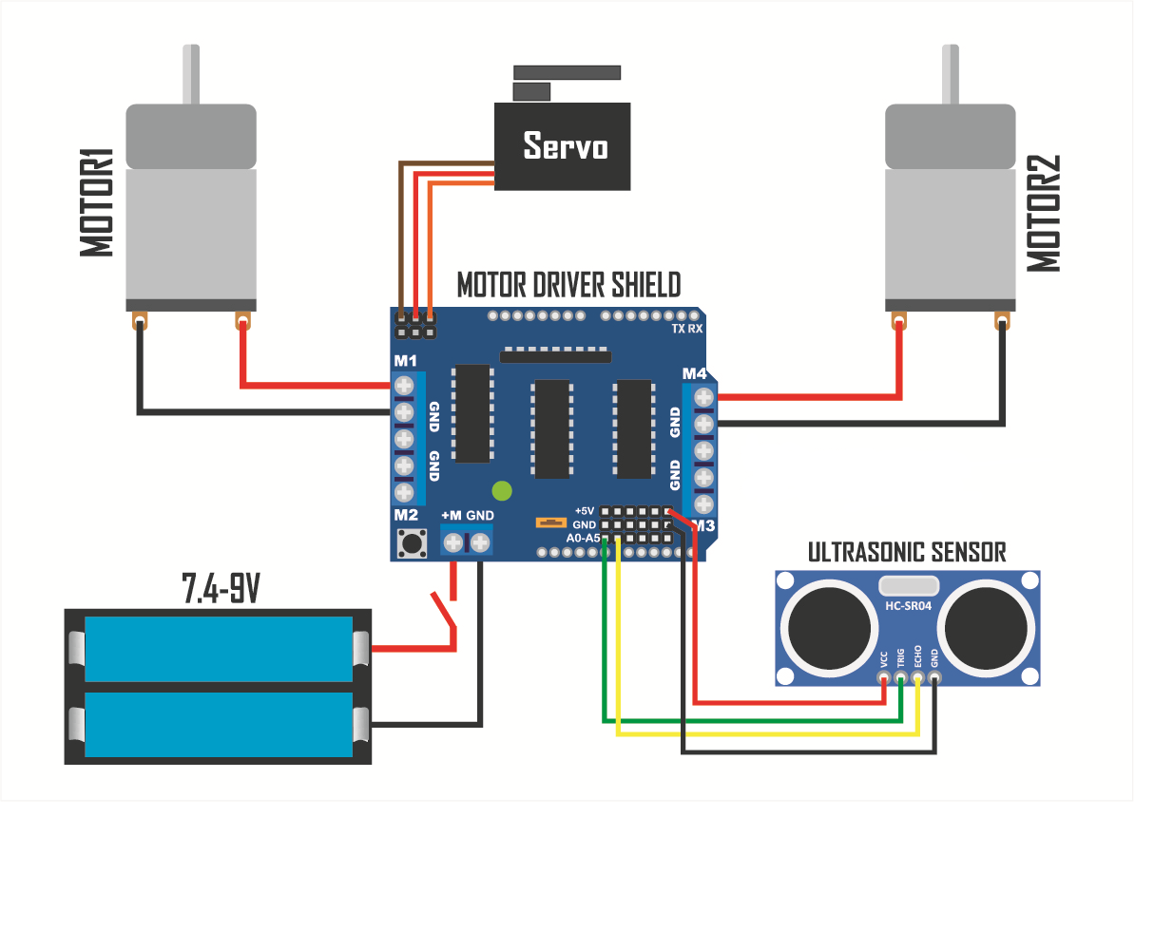

**Programming the Robot-**

The Arduino microcontroller communicates with the PC via the USB connection. Data is transferred between the board and the PC bit by bit. An adaptor is used for power supply to the board and a USB programmer is used to burn the hardware program (written in Arduino IDE) into the board.

**Flowchart of the Program**

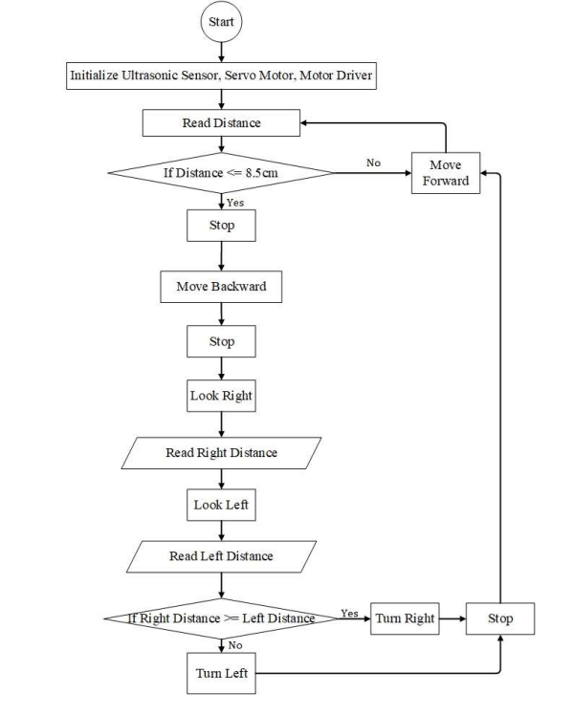

**Use Case Diagram**

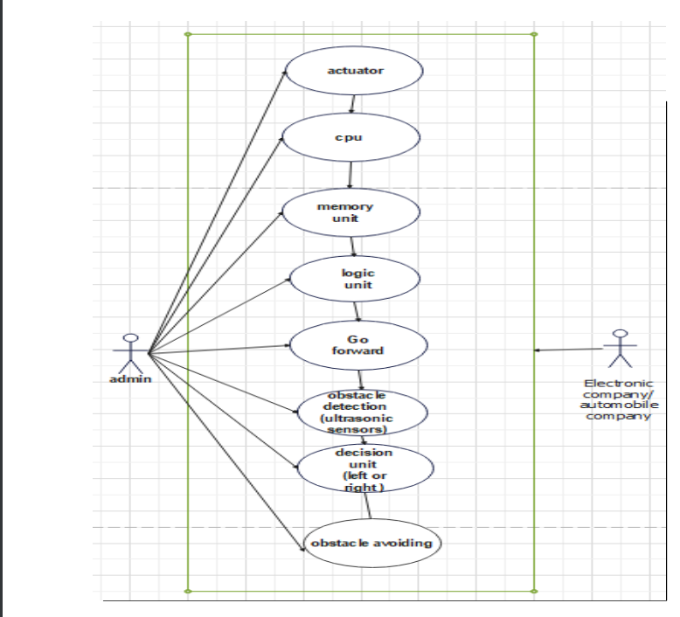

**Chapter7**

**RESULTS**

The outcome of this thesis is a simple, Arduino-controlled robot car which moves around detecting obstacles in its way and avoiding them.. When the wave strikes an obstacle, it bounces back and the distance is stored for the front, right, and left position. After this, the microcontroller compares the values based on its algorithm and determines whether to move forward or change path. Tests carried out on the final hardware revealed the limitations of the detection algorithm. The limitations were related to cases of some obstacles not being detected and this was as a result of the sensor not being able to measure obstacles outside the measuring range of the sensor. When an object is in the way of the car and this object is not within the line of sight of the sensor, it will not be detected thereby leading to collision. To avoid this, the testing was further carried out in an enclosed area where the wall is the only obstacle and the car was able to move freely without collision. To implement a car which will detect multiple obstacles and avoid them, more sensors have to be used in order to cover a wider range for obstacle detection.

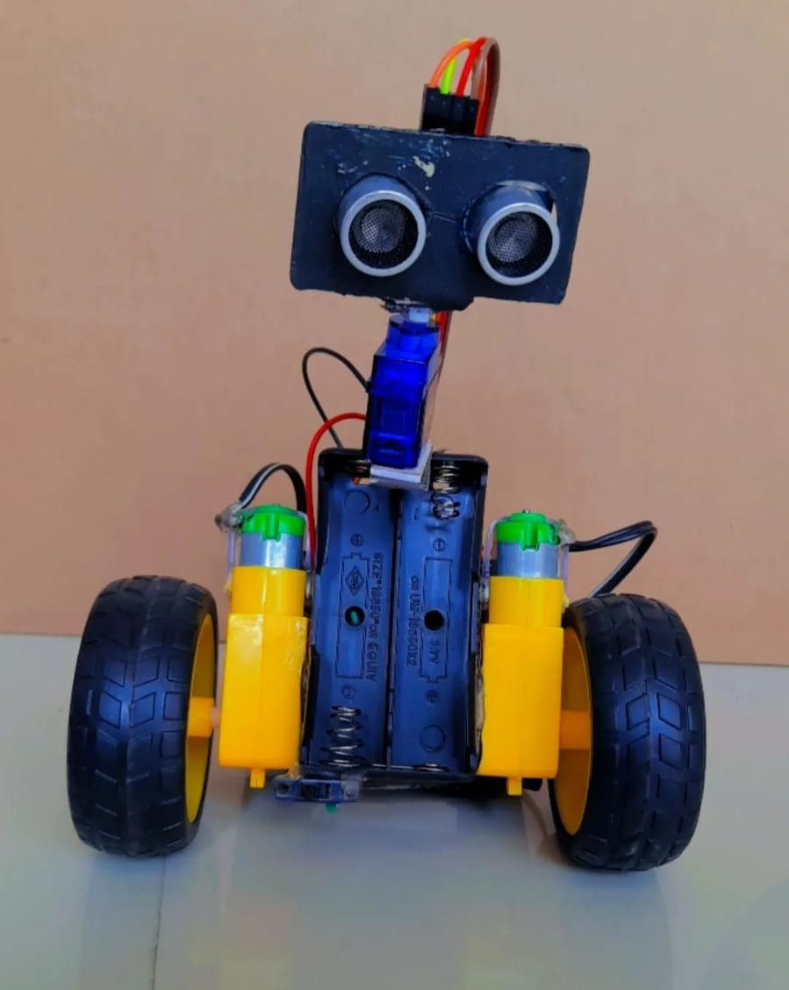

**Applications-**

1.Used in mobile robot navigation systems

2. Used for household work like automatic vacuum cleaning

3. Used in dangerous environments, where human penetration could be fatal.

4. Automatic change over’s of traffic signals

5. Intruder alarm system

6. Counting instruments access switches parking meters

7. Back sonar of automobiles

**Chapter8**

**CHALLENGES FACED**

Although the concept and design of the project seemed perfect, there were some problems faced while actual implementation: The sensor cannot accurately measure distance to an object if:

* Object > 3 meters
* Too shallow of angle
* Object is too small
* object surface is not reflective

**Chapter9**

**CONCLUSION**

Today we are in the world of robotics. Knowingly or unknowingly, we have been using different types of robots in our daily life. The project is “obstacle detection and the avoidance robot” is practically proved by using the Ultrasonic sensor for sensing the robot, Motor Shield Driver for the driving the dc motors, dc motor is used for the movement of the robot with the help of the Arduino Microcontroller. A lot of factors determined the accuracy of the robot we designed. These factors were the environmental phenomenon in which the robot was tested, the number of obstacles present making the test space crowded or relatively less crowded the type and shape of the obstacle (the robot is designed for a uniform shaped obstacle). These factors majorly affected the sensors. The accuracy of the robot is dependent on the sensors used. Thus, the nature of the sensor and its accuracy defined the accuracy of my robot

**FUTURE SCOPE**

* To enable robots to be able to adapt to its environment is an important domain of robotics research. Whether this environment be underwater, on land, underground, in the air or in space. A fully autonomous robot has the ability to
* Work for an extended period of time without intervention from human or a need for power supply.
* Avoid situations that are harmful.
* Move either all or part of itself throughout its operating environment.
* The most effective method to increase the accuracy of my robot is the inclusion of better sensors, although the project cost might increase but the accuracy will definitely increase as well as the problem space where the robot can be used. Better actuators will result in a faster and more efficient robot.
* Adding a Camera: If the current project is interfaced with a camera (e.g. a Webcam) robot can be driven beyond line-of-sight & range becomes practically unlimited as networks have a very large range.
* Use as a fire fighting robot: By adding temperature sensor, water tank and making some changes in programming we can use this robot as firefighting robot.
* We can extend this project with wireless technology by IR (or) RF (or) ZIGBEE.
* We can use the DTMF receiver by using the mobile phone.
* This robot can be used for pick and place the required object by giving directions to the robot but ultrasonic sensor should be replaced depending upon the application.

**Chapter10**

**REFERENCES**

1. N. Senthil Kumar,M.Saravanan,S Jeebananthan ,“Microprocessors & Microcontrollers”, Oxford University Press,4th Edition,2012,ISBN:978-0- 19-806647-7
2. Vision-based obstacles detection for a mobile robot ElHalawany, B.M.; Abdel-Kader, H.M.; TagEldeen, A.; Ahmed, A.E.S.; Nossair, Z.B. Informatics and Systems (INFOS), 2012 8th International Conference on Year: 2012
3. T. Ishida, and Y. Kuroki, “Sensor System of a small Biped Entertainment Robot”, Advanced Robotics, © VSP and Robotics Society of Japan,Vol. 18, No. 10, pp 1039-1052, 2004,
4. Arduino Step by Step Book
5. J. Grefenstette and A. Schultz. “An Evolutionary Approach to Learning in Robots” Machine Learning Workshop on Robot Learning, New Brunswick, 1994.
6. Marija Seder. “Hierarchical Path Planning of Mobile robots in Complex Indoor Environments”, June 2011, University of Zagreb.
7. B. Ram, “Fundamental of Microprocessors & Microcontrollers”, Dhanpat Rai Publication,Seventh Edition, ISBN:978-81-89928-60-5
8. M. C. Lam, A. S. Prabuwono, H. Arshad, C. S. Chan, “A Real-Time Vision-Based Frameworkfor Human-Robot Interaction”, , 7066Lecture Notes .in Computer Science (Part 1),2011, pp. 257-267, IVIC 2011.
9. http://science.howstuffworks.com/robot2.htm
10. http://en.wikipedia.org/wiki/Robotics
11. http://en.wikipedia.org/wiki/Artificial_intelligence
12. http://www.alldatasheet.com/
13. https://www.adafruit.com
14. https://www.arduino.cc
15. <https://playground.arduino.cc/Code/NewPing>
16. https://www.arduino.cc/en/Reference/Servo